Serverless Development 101

**HOP01C – AWS Account Registration**

1/10/2019 Developed by Kevin Wang

1/17/2019 Revised by Clark Jason Ngo & Sam Chung

Center for Information Assurance (CIAE) @City University of Seattle (CityU)



**Learning Outcomes**

* Learn how to register for an AWS account

**Registering an AWS account**

1. Visit <https://aws.amazon.com/>

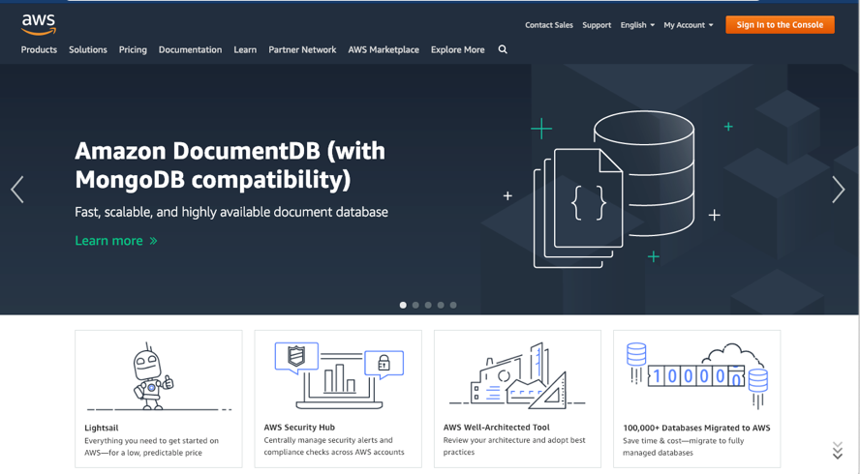

1. If you already created your AWS Account, go to the step 6.   
   Otherwise, click “Create an AWS Account” button on the top-right corner



1. Fill out the form (use your own information) and click the “Continue” button

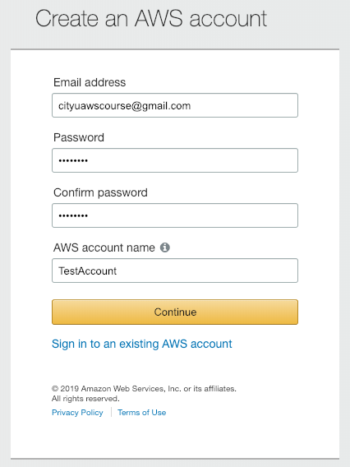

1. Fill out the Account type form and click the "Create Account and Continue” button

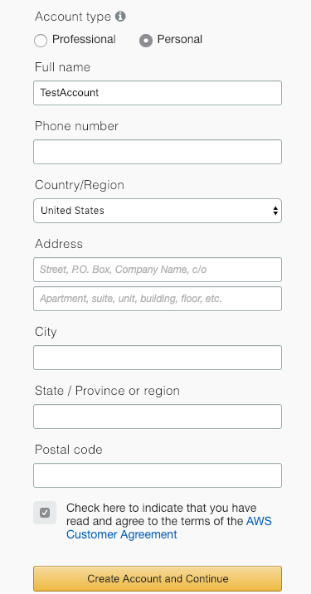

1. Fill out the Payment Information form (You will not be charged since AWS offers a one-year free tier. All AWS services that we’ll be using are included in the free tier)

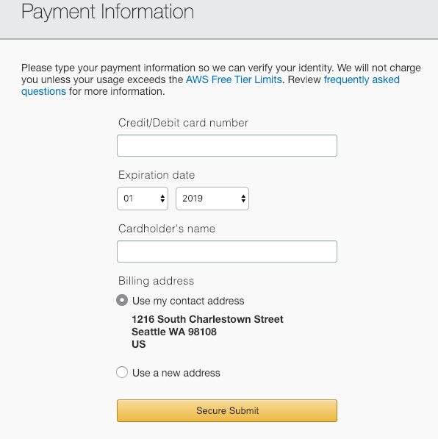

1. After making your account, “Sign in to the Console”

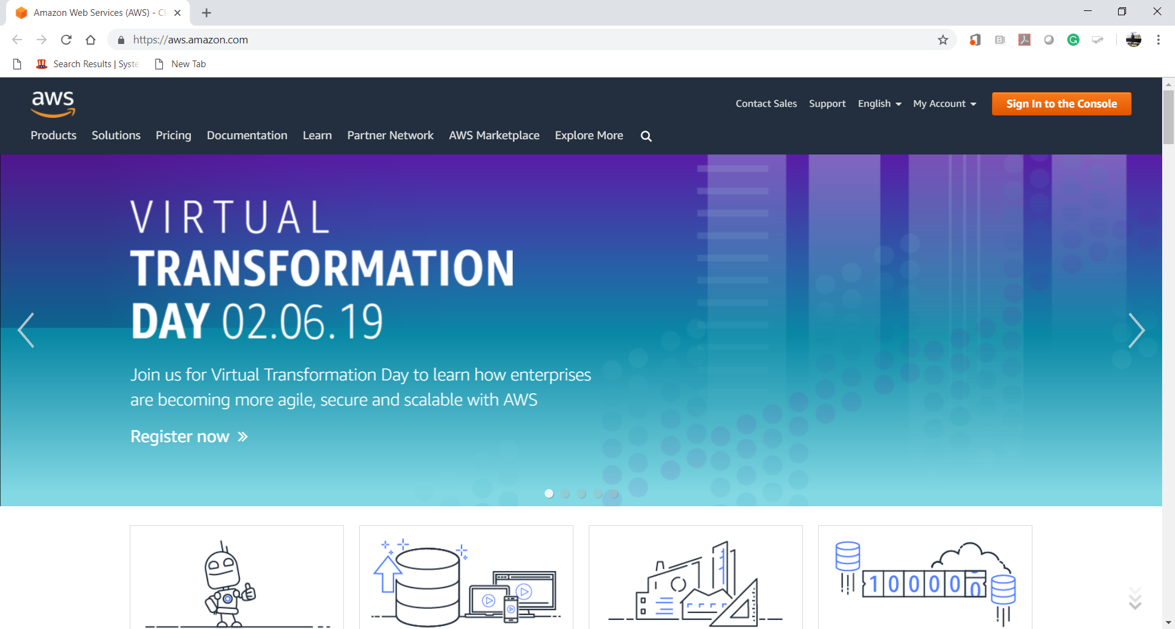

1. Explore “AWS Management Console.”

